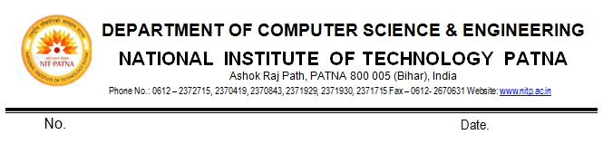
NOTICE

The students of M.Tech (CSE) 4th Semester and M.Tech (IT) 4th Semester are hereby informed that their Final Dissertation (4CSS695/4IT695) and Seminar and Comprehensive Viva (4CS694/4IT694) to be conducted online as per given schedule below.

The students prepared with PPT slides of their online presentation.

Date | Timing | Subject & Code | Roll No. | Students Name
23rd June 2020 | 9:00 AM to  01:00 PM | M.Tech, Dissertation (4CS695/4IT695) &  Seminar and Comprehensive Viva (4CS694/4IT694) | 1828010 | PURNIMA GAUTAM
 |  |  | 1828016 | RAVITE ANAND
 |  |  | 1828015 | VIKASH KUMAR
 |  |  | 1832007 | NIDHI OJHA
 |  |  | 18CS001 | ASHIMA ANAND
23rd June 2020 | 01:00 PM to  05:00 PM | M.Tech, Dissertation (4CS695/4IT695) &  Seminar and Comprehensive Viva (4CS694/4IT694) | 1828007 | SAHIL VERMA
 |  |  | 1828017 | PRASHMIT TANAY
 |  |  | 1832003 | SURYAKANT BALAJI BADDE
 |  |  | 1828006 | BANVOTH RAJASHEKHAR
 |  |  | 1832006 | VIKASH BAJORIA
24th June 2020 | 9:00 AM to  01:00 PM | M.Tech, Dissertation (4CS695/4IT695) &  Seminar and  Comprehensive Viva (4CS694/4IT694) | 1828002 | RAZIA
 |  |  | 1828005 | TATA SRIRAM
 |  |  | 1828009 | ARCHANA TIWARI
 |  |  | 1828008 | PRAGYA HARI
 |  |  | 18IT002 | AMAR JINDAL
24th June 2020 | 01:30 PM to  05:30 PM | M.Tech, Dissertation (4CS695/4IT695) &  Seminar and Comprehensive Viva (4CS694/4IT694) | 1828003 | NEHA SINGH
 |  |  | 1828012 | RADHIKESH KUMAR
 |  |  | 1832005 | SHWETA SINGH
 |  |  | 18CS002 | PRERANA KUMARI
 |  |  | 1828018 | PRATITI DAS
 |  |  | 1832008 | POOJA KUMARI
25th June 2020 | 9:00 AM to  01:00 PM | M.Tech, Dissertation (4CS695/4IT695) &  Seminar and Comprehensive Viva (4CS694/4IT694) | 1832010 | ITYENDU PARHI
 |  |  | 1828001 | SONAL KUMAR
 |  |  | 1828004 | ARJUN MAKWANA
 |  |  | 1832009 | SURYA DHANRAJ
 |  |  | 18IT001 | CHHOTELAL KUMAR

PG Coordinator HOD

Copy to:
1. Concerned faculty Members
2. Notice Board
3. Guard File

